EX NO:9 RECOMMENDATION SYSTEM USING COLLABORATIVE FILTERING
DATE: TECHNIQUES

SCENARIO 1: USER-BASED COLLABORATIVE FILTERING:
HEATMAP:

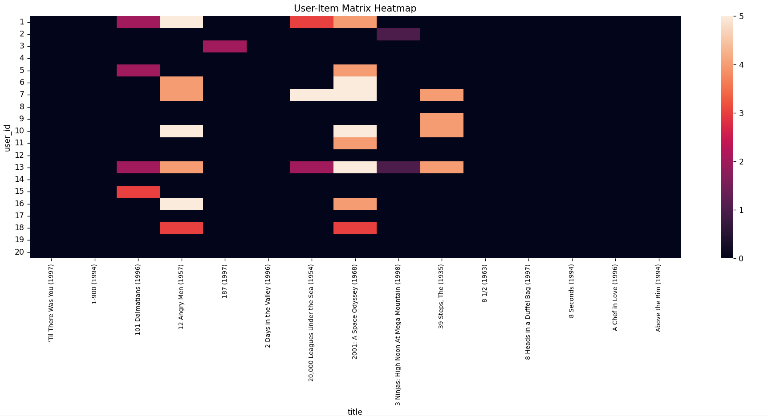

USER SIMILARITY MATRIX:
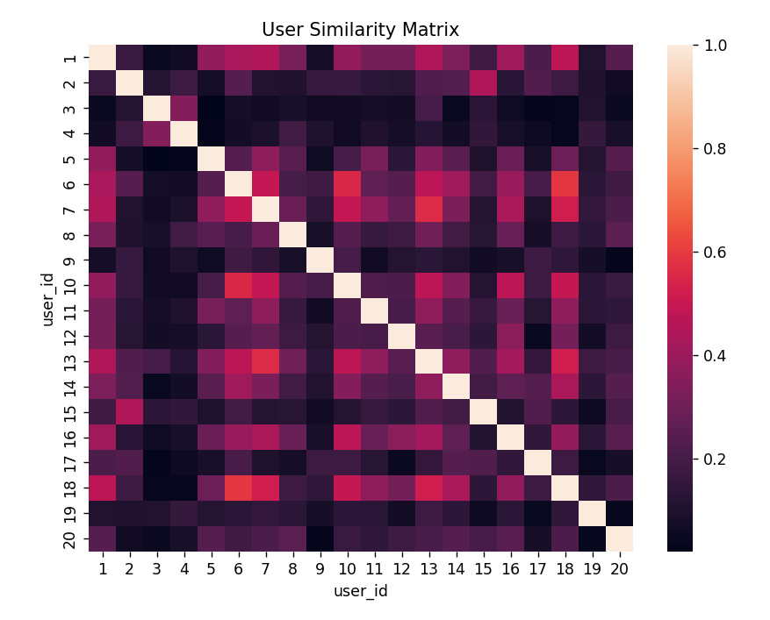
TOP RECOMMENDATION:
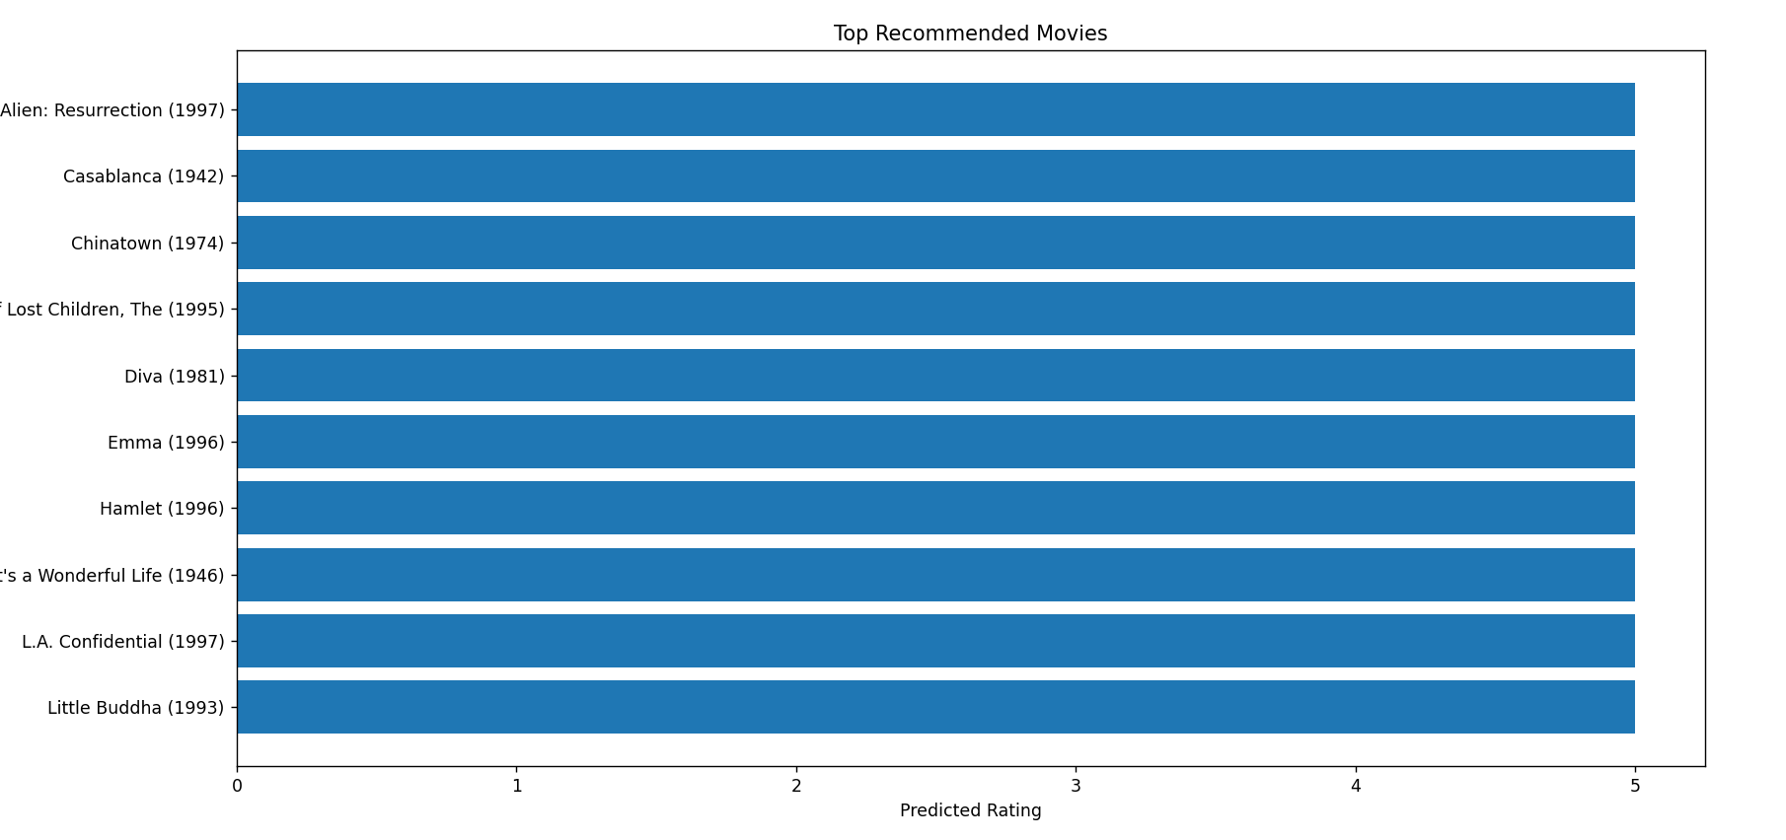
SCENARIO 2: ITEM-BASED COLLABORATIVE FILTERING:
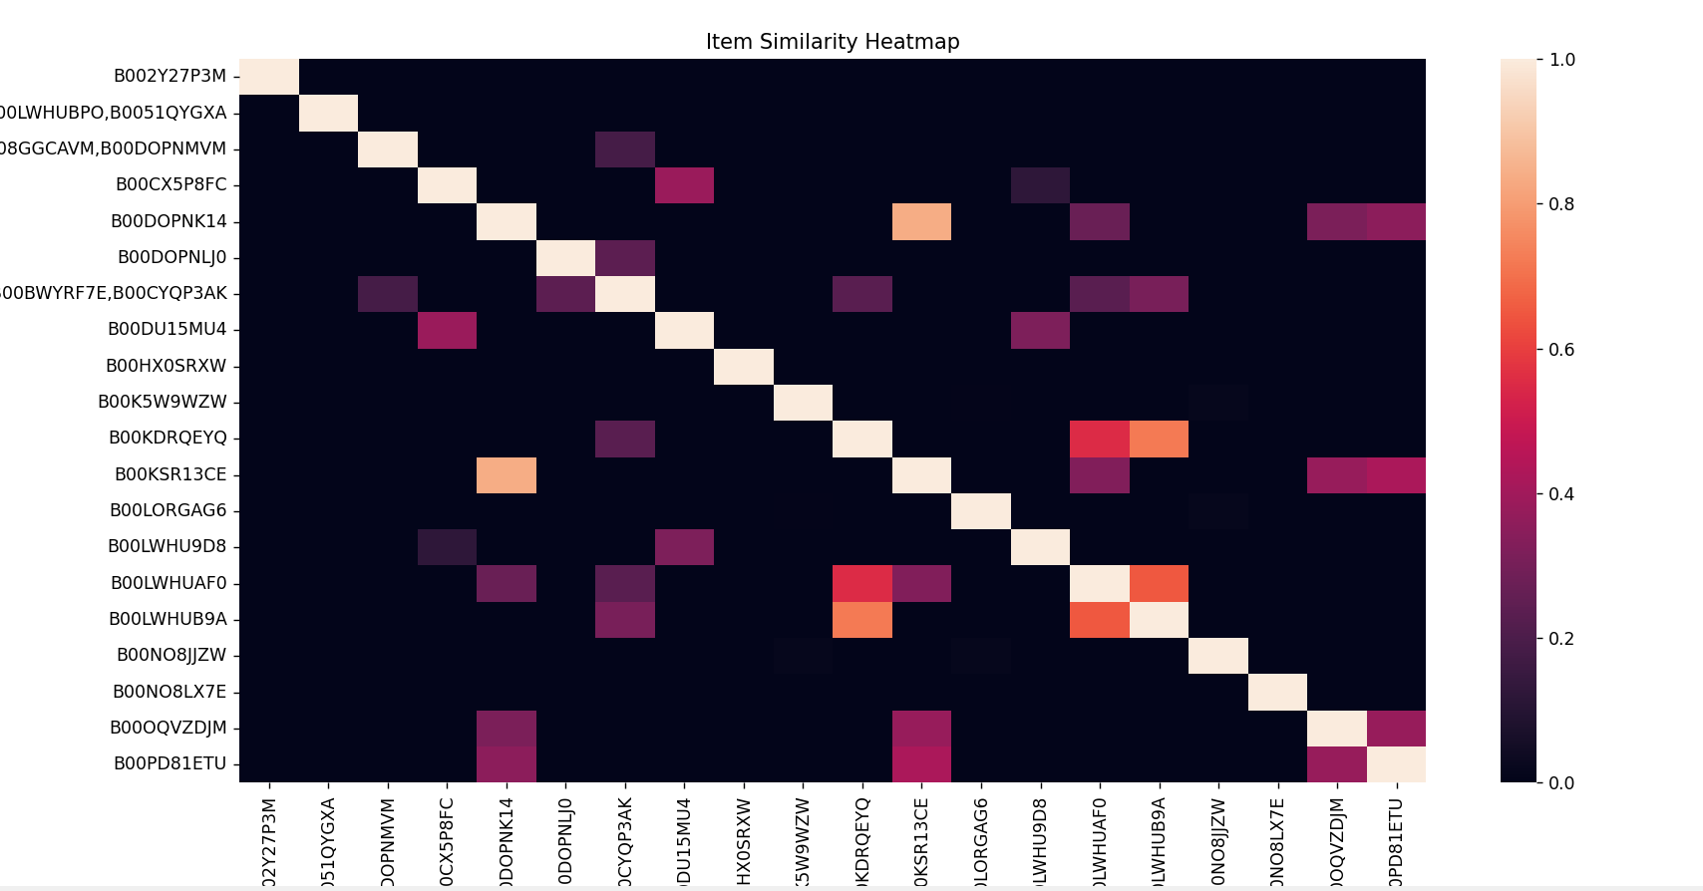

TOP SIMILAR ITEMS:
